CPE Programming 2 Final Project Proposal

Project title: Pacres Integrated Learning Application (PILA)

Member: John Emmanuel Pacres

**Project Description:**

The Pacres Integrated Learning Application (PILA) is a comprehensive educational tool designed to assist students in their learning as well as teachers to manage student grades and performance. It will provide features such as quiz games, reading level test, and a progress manager to help teachers monitor their student’s academic status.

**Technical Details**

* **Concept Utilized**

Functions

Arrays

Pointers

Dynamic Memory Allocation

Structures

File Handling

* **Implementation plan**
* Design the user interface and different modules (quiz game for student mode, reading level tracker for teacher mode, and progress tracker for both modes).
* Implement functions for each module to handle user interactions.
* Utilize arrays and structs to store user data.
* Use pointers for efficient memory management, especially in dynamically allocating memory for user progress data.
* Implement file handling function to give option for user to save their data in a file.

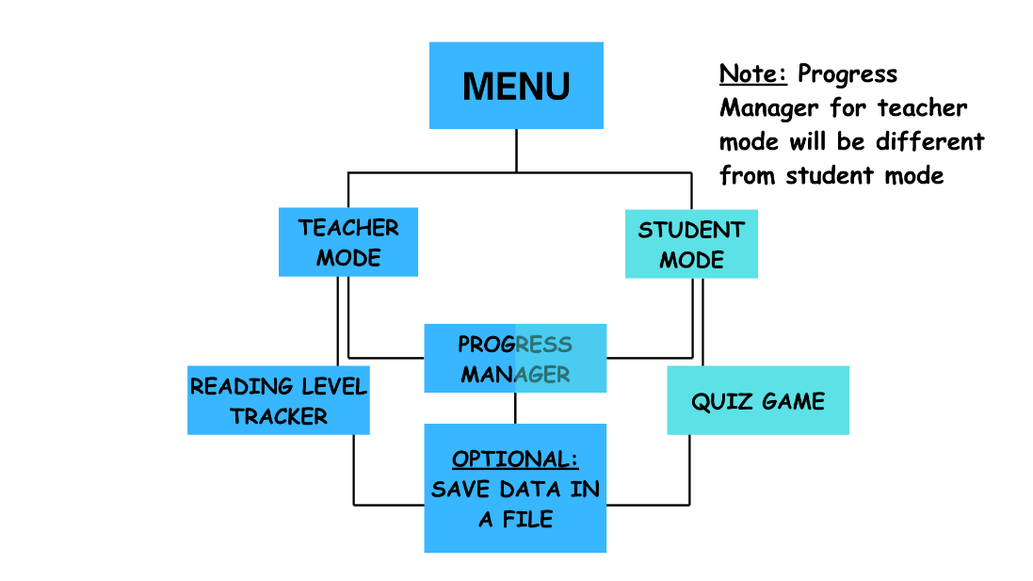

* **Challenges and Solutions**
* Challenge: Efficient memory management for dynamic data.

Solution: Utilize pointers and dynamic memory allocation to optimize memory usage and prevent memory leaks.

* Challenge: Implementing complex algorithms for quiz game and reading level tracker.

Solution: Break down the algorithms into manageable functions and utilize arrays and structures to store necessary data for processing.

* Challenge: Time Constraint

Solution: Eliminate tedious features and ensure the major functions are implemented.

* Challenge: Save data for future use.

Solution: Using file handling functions such as fread, fwrite, fflush etc. to help teachers and students keep and organize their data.

**Project scope**

* Develop a comprehensible interface with menu options for different functionalities.
* Implement a quiz game, whether multiple choice or wordle type game (or another concept).
* Design reading level calculator based on the text that the user will input.
* Create a progress manager to monitor user performance and store data for analysis.
* Some concepts like advanced algorithms might be tedious to implement.

**Timeline**

* **May 3 – 11** – Coding
* **May 11 – 16** – Debugging
* **May 17** – Program presentation

**Resources**

Book/s:

* C Programming Language by Brian Kernighan & Dennis Ritchie
* Designing Data-Intensive Applications by Martin Kleppmann

Websites:

* <https://www.onlinegdb.com/>
* <https://citu.codechum.com/>
* <https://manual.cs50.io/>
* <https://stackoverflow.com/>
* <https://www.programiz.com/>
* <https://www.youtube.com/watch?v=u-AMQulSbM8&ab_channel=CodeTic>
* <https://www.youtube.com/playlist?list=PLfVsf4Bjg79BOmLYBRTwqCIkGPiOWb7xj>